**Using NPN and PNP BJT as Circuit protection (Breaker)**

NPN Circuit:

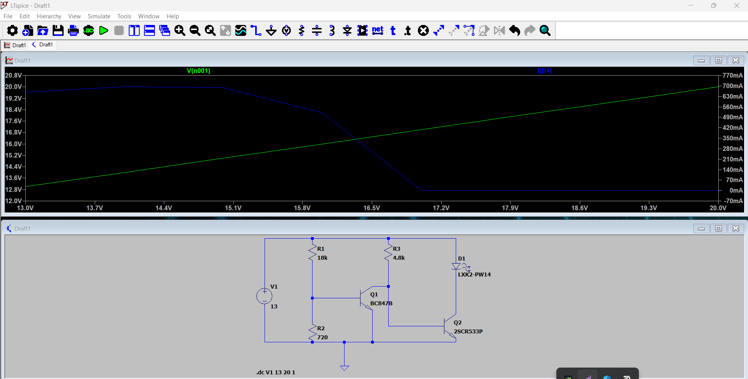

**1. Introduction**

Reverse polarity protection is essential in electronic circuits to prevent damage caused by incorrect connection of the power supply. The NPN transistor-based protection circuit shown in the image is a popular method to safeguard sensitive components from reverse voltage.

**2. Circuit Description**

The circuit diagram consists of the following key components:

* **NPN Transistor (Q1)**
* **NPN Transistor (Q2)**
* **Resistors (R1 and R2)**
* **Diode (D1)**
* **Load**

In NPN circuit we use it as a low side of the load.

Load connected directly to the power supply and the transistor is midway between the ground and the load.

When the power supply is connected correctly, the base of the NPN transistor (Q1) receives a small positive voltage relative to the emitter, turning Q1 on.

With Q1 turned on, current flows from the power source (V1) through the collector-emitter junction of Q1, allowing the circuit to function normally.

Q2, which is a PNP transistor, remains off due to the potential difference across its junctions, preventing any current flow through the load (D1).

If the power supply is connected with reverse polarity, the base of Q1 becomes negative relative to its emitter, turning Q1 off.

When Q1 is off, there is no current flow through its collector-emitter junction, effectively disconnecting the circuit and preventing damage.

The LED (D1) remains off since Q2 is not activated, ensuring that no current flows through the load.

As we see in the figure when the value if voltage exceeds 18 volt the load is switched off and the current passing through it is zero.

PNP circuit:

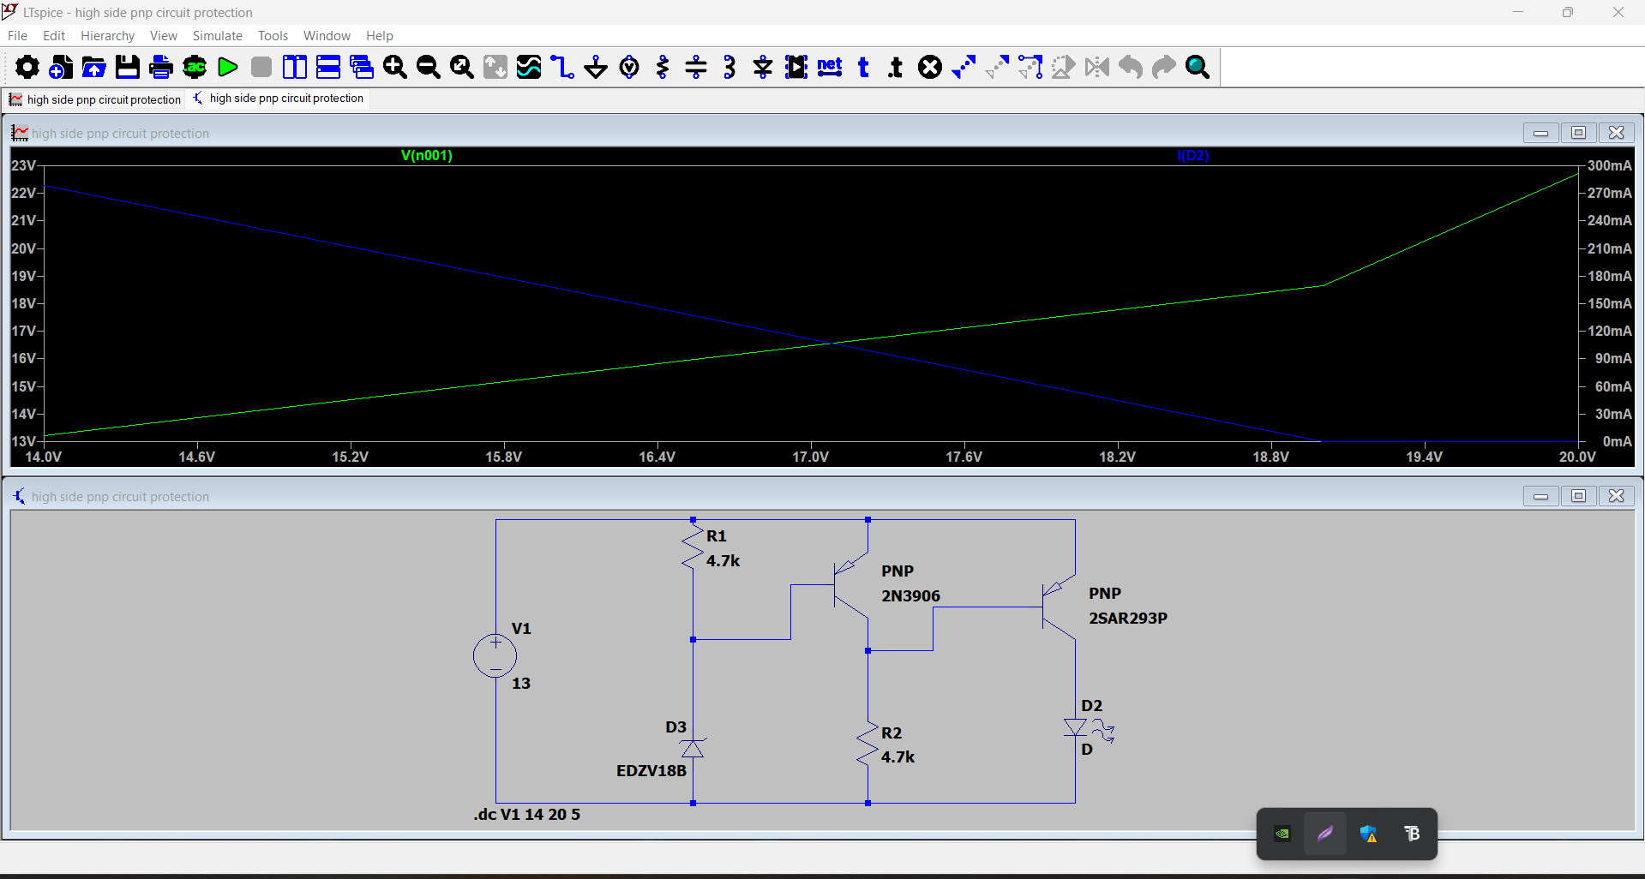

**1. Introduction**

Reverse polarity protection is essential in electronic circuits to prevent damage caused by incorrect connection of the power supply. The PNP transistor-based protection circuit shown in the image is a popular method to safeguard sensitive components from reverse voltage.

**2. Circuit Description**

The circuit diagram consists of the following key components:

* **PNP Transistor (Q1)**
* **NPN Transistor (Q2)**
* **Resistors (R1 and R2)**
* **Diode (D1)**
* **Load**

In PNP circuit we use it as a high side of the load.

Load isolated from the power supply and the transistor is midway between the voltage source and the load.

When the power supply is connected with the correct polarity, the base of the PNP transistor (Q1) is at a lower potential than its emitter, allowing Q1 to turn on.

The base of the NPN transistor (Q2) is driven by the current flowing through Q1, turning Q2 on. As a result, current flows through the load, and the circuit operates normally.

If the power supply is connected with reverse polarity, the base of Q1 becomes more positive relative to its emitter, preventing it from turning on.

Since Q1 remains off, no current flows to the base of Q2, keeping Q2 off as well. Consequently, the circuit remains inactive, and the load is protected from damage.

As we see in the figure when the value if voltage exceeds 18 volt the load is switched off and the current passing through it is zero.

The diode D1 is included to protect the base of Q1 from any reverse bias voltage. It ensures that Q1 remains off during reverse polarity conditions by preventing any unwanted current flow.